**Multiple Aspect Ranking using the Good Grief Algorithm**

**1 Introduction**

The algorithm presented in this paper models the dependencies between different labels via *the* *agreement relation*. The Good Grief model consists of a ranking model for each aspect as well as an agreement model which predicts whether or not all rank aspects are equal. Our model significantly outperforms individual ranking models as well as a state-of-the-art joint ranking model.

**2 Related Work**

**Sentiment Classification**

**Ranking** The ranking, or ordinal regression, problem has been extensivly studied in the Machine Learning and Information Retrieval communities.

**3 The Algorithm**

The goal of our algorithm is to find a rank assignment that is consistent with predictions of individual rankers and the agreement model.

**3.1 Problem Formulation**

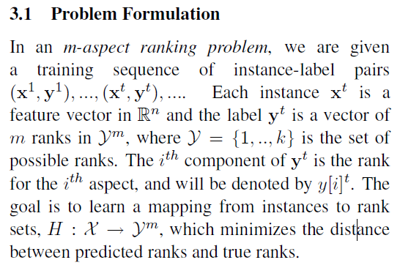

**3.2 The Model**

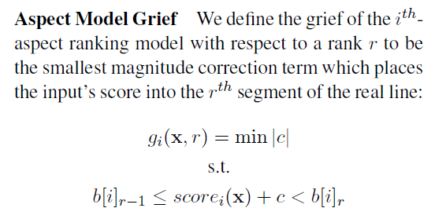

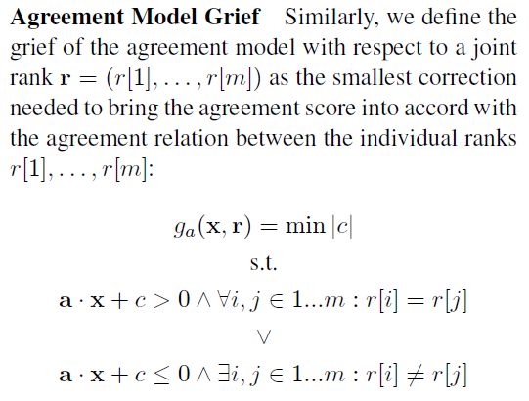

**3.3 Training**

**Ranking models**

**Agreement model**

**3.4 Feature Representation**

**Ranking Models** Following previous work on sentiment classification (Pang et al., 2002), we represent each review as a vector of lexical features. More specifically, we extract all unigrams and bigrams, discarding those that appear fewer than three times. This process yields about 30,000 features.

**Agreement Model** The agreement model also operates over lexicalized features. The effectiveness of these features for recognition of discourse relations has been previously shown by Marcu and Echihabi (2002). In addition to unigrams and bigrams, we also introduce a feature that measures the maximum contrastive distance between pairs of words in a review. For example, the presence of *.delicious.* and *.dirty.* indicate high contrast, whereas the pair *.expensive.* and *.slow.* indicate low contrast. The contrastive distance for a pair of words is computed by considering the difference in relative weight assigned to the words in individually trained Pranking models.

**4 Analysis**

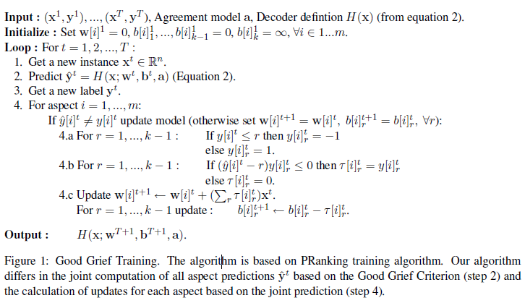

**5 Experimental Set-Up**

**6 Results**

**7 Conclusion and Future Work**

We considered the problem of analyzing multiple related aspects of user reviews. The algorithm presented jointly learns ranking models for individual aspects by modeling the dependencies between assigned ranks.